**Name: Jyoshi Harish Chandra,Class ID- 09,Team 8-2**

**Technical partner Details:**

**Name: Sai Nagarjuna Kolla,Class ID- 12,Team 8-2**

**Contribution:**

Jyoshi Harish Chandra: Webservice 1(Clarifai API),Karma and Jasmine Test Cases and UI(50%),

Sai Nagarjuna Kolla: Webservice(Uclassify API),Login and register pages,YSlow.(50%)

**Plugins used :** 1.Clarifai plugin 2.Camera Plugin 3.Firebase plugin

For this Lab Assignment we created an ionic application which have below features.

**A. Login/Registration using Firebase Authentication.**

1.Created an ionic application with blank template.

2.Created a login and register page with email and password as the inputs.

3.Created a project in the Firebase and authenticate with the login and register page created in ionic.

4.User can register with the email and password that will be stored in the firebase cloud.

5.After registering, the user can login with the email and password created and navigate to the Home Screen

Login page

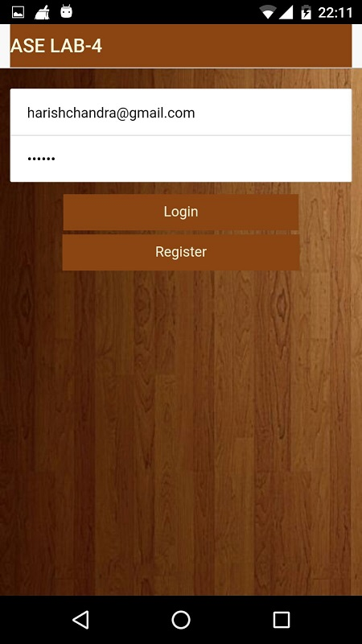

**Firebase Authentication**

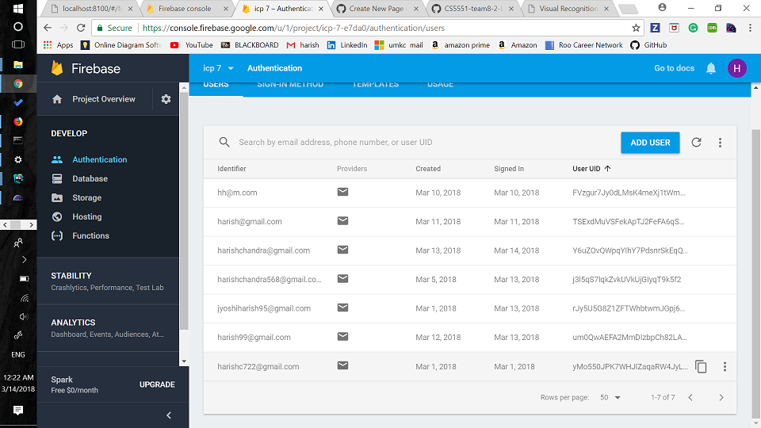

## ****B. Web service 1 using Clarifai API****

1.This web service is used to visualize the images requested to API.

2.User can uplaod a image using the camera in the mobile.

3.Once image is uploaded, we can see the image on the home screen

4.We can get the prediction of the image by requesting the base64 format of the image to the Clarifai Rest API

5.Once the request has made, the API returns top 10 results in the form of JSON

**Code snipppet of Clarifai API**

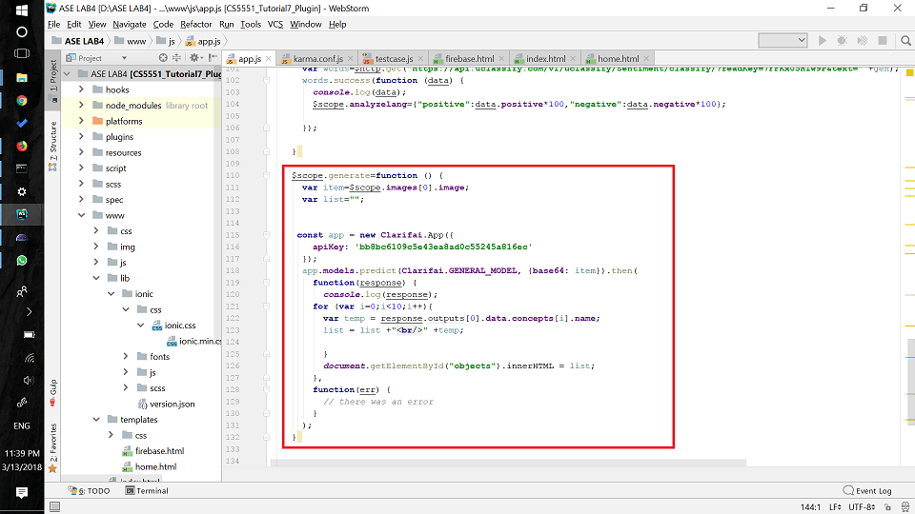

**Home page and Camera access**

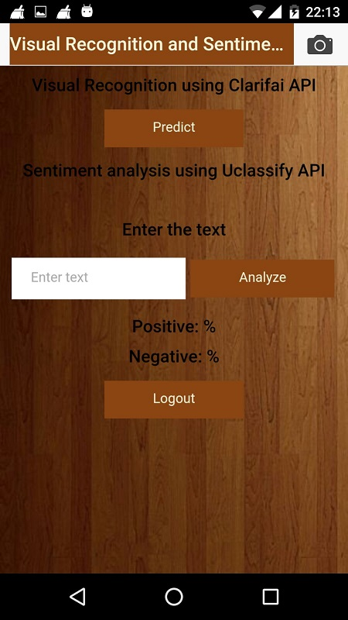 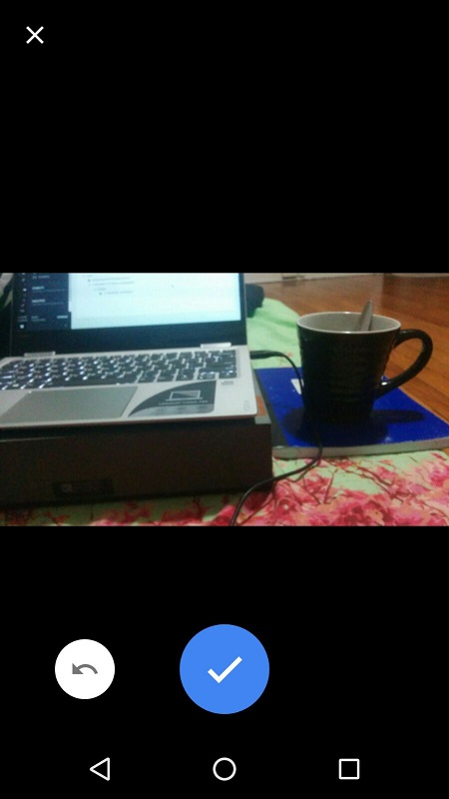

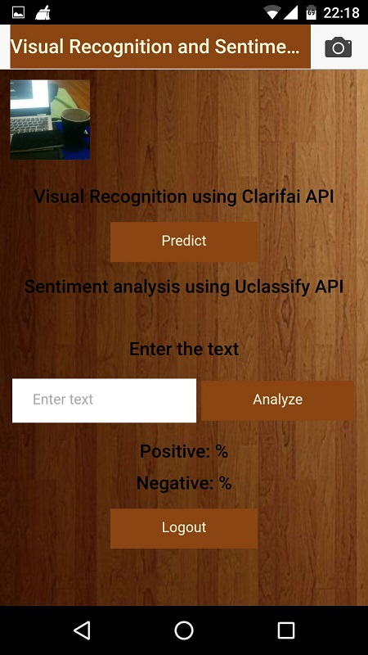**Image upload alert and Image uploaded**

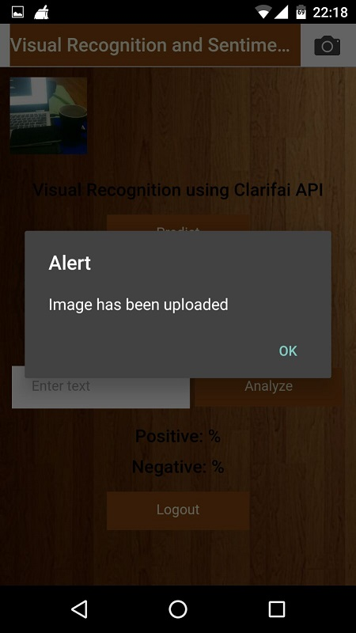

**Clarifai prediction**

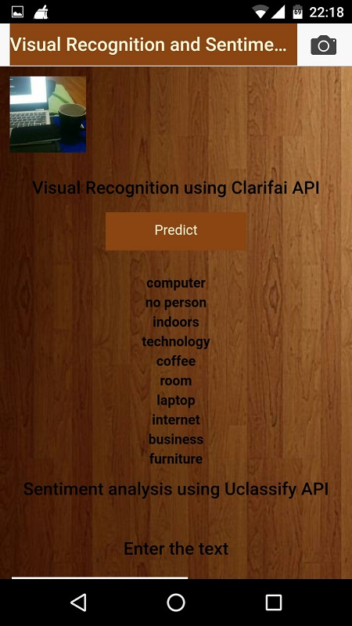

## ****C.Web service 2 using Uclasssify API****

1.This web service is used to get the sentiment analysis.

2.User enters the text in the text field and clicks on the analyze button.

3.Once the request is made, the API returns the postive and negative percentage of the text entered.

**Code snippet of Uclassify API**

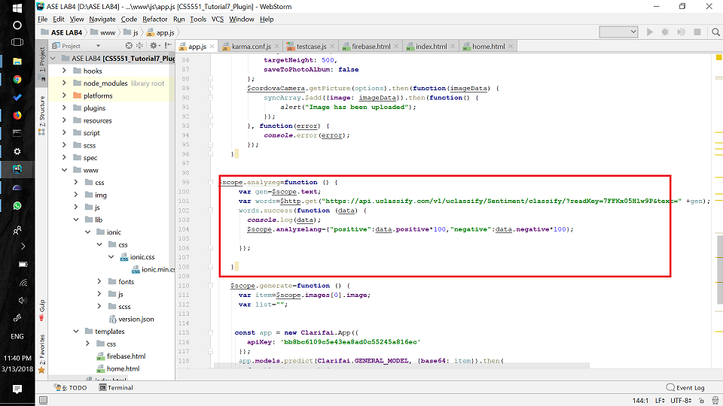

**Results when various inputs are entered**

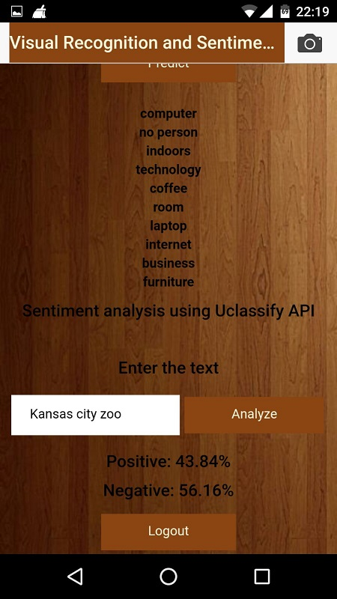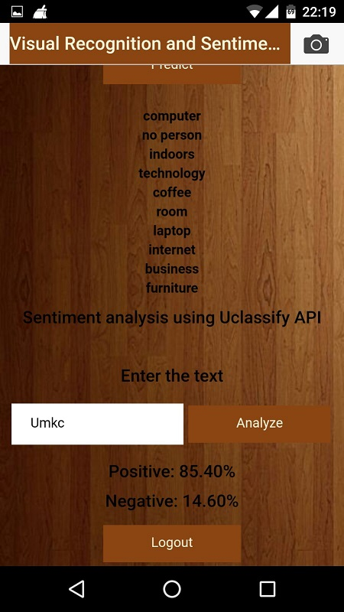

## ****D.Plugins Used:****

**1.Clarifai plugin is installed via npm using npm install clarifai command**

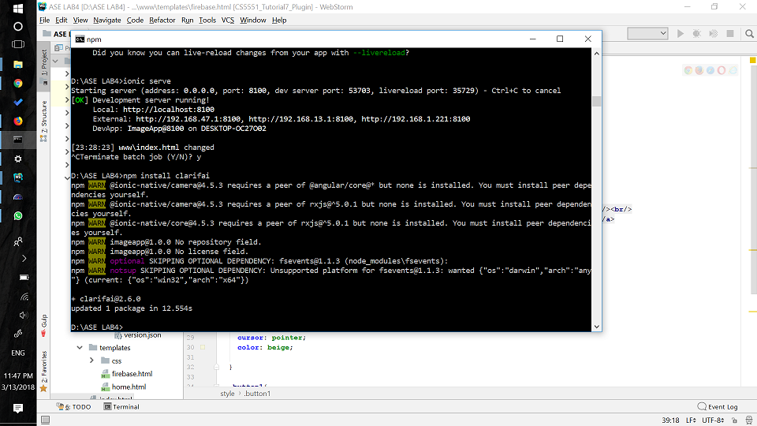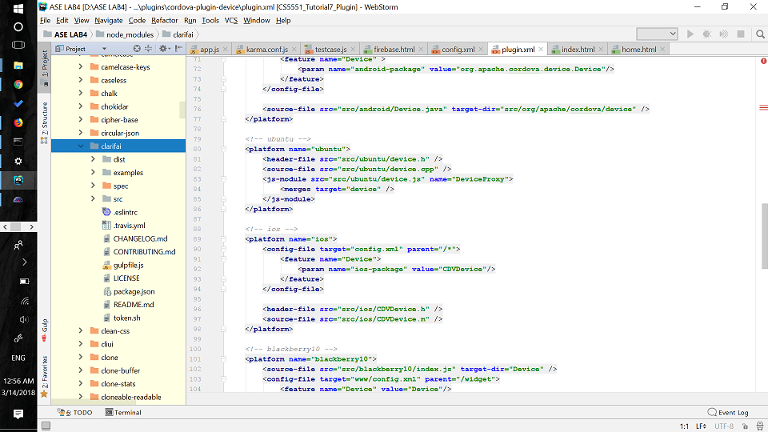

**2.Camera Plugin is used in this assignment which we are going to use in our project**

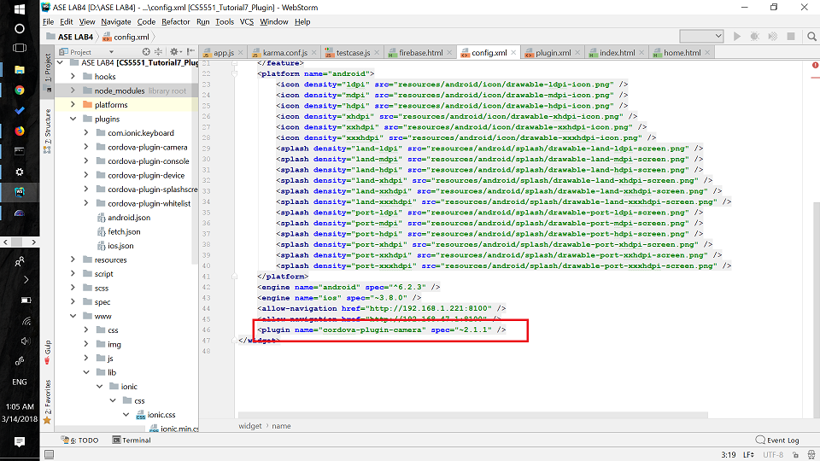

**3. Firebase plugin is used in this assignment which we are going to use in our project**



## ****E.Karma and Jasmine Unit test cases****

1.We have written 3 unit test cases for the login page using karma and jasmine framework.

2.Navigate to the Ionic project and go to the node_modules folder.

3.Install the karma and jasmine modules.

4.Now create karma.conf JS file using.

5.Add the files of source and test cases into the karma config file.

6.Now create three test cases in angular js file.

7.We have created test cases for username and password to check if the username is empty, password is empty and both username , password is empty.

8.Test cases are executed through the karma.conf.js file and results are executed in the console.

**karma.config page**

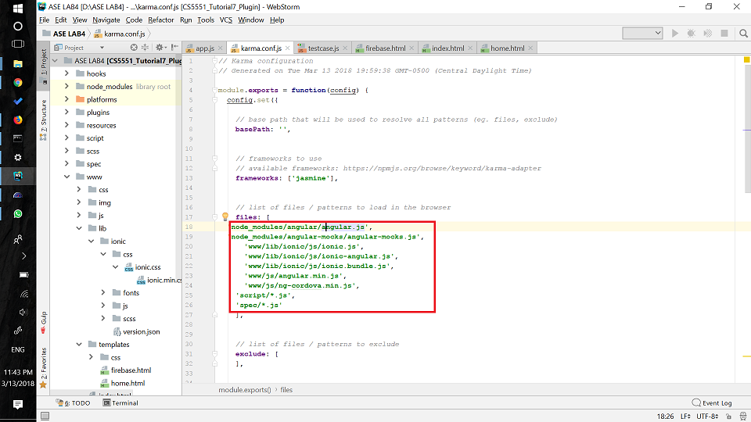

**Test cases js page**

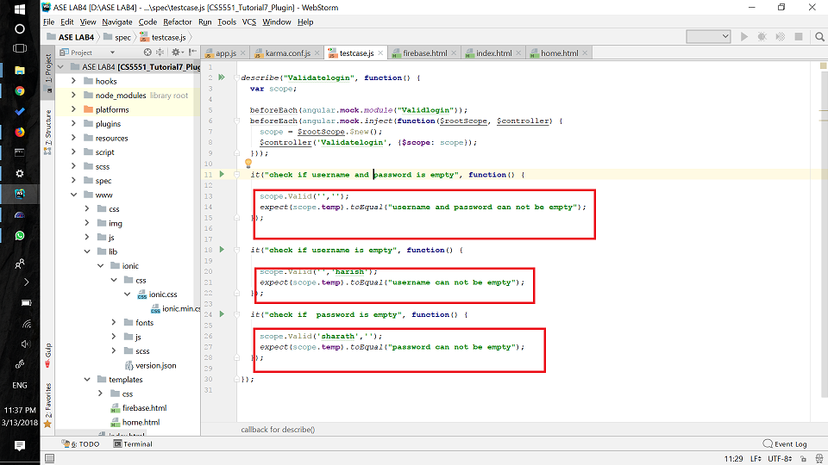

**Execution of test cases**

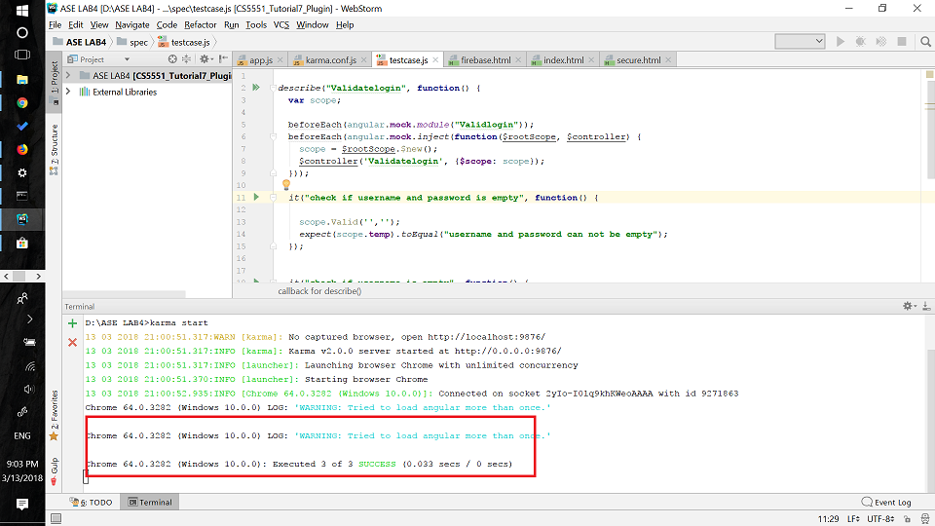

## ****F.Performance Testing using YSlow****

1.Installed the YSlow extension for chrome browser and started the application.

2.We can see the results, grades and statistics of the application from the Yslow.

**Graded C in Login page**

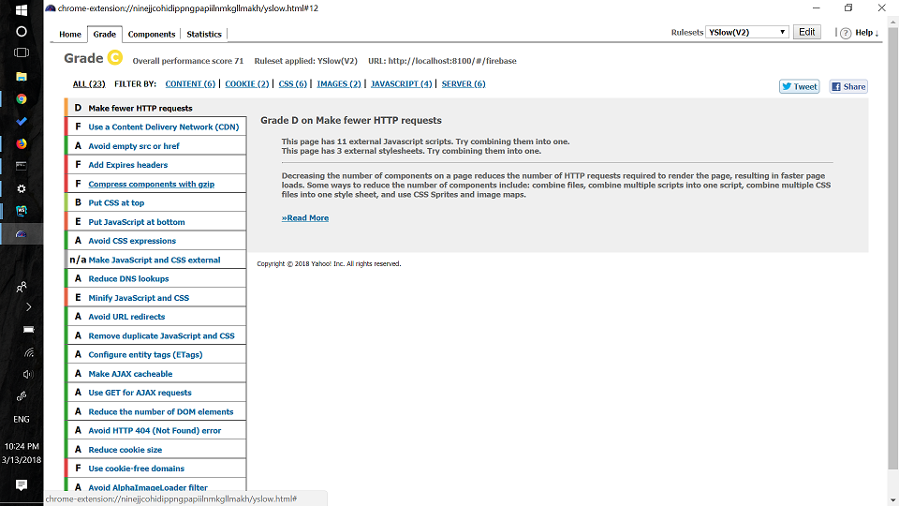

**Login page statistical report**

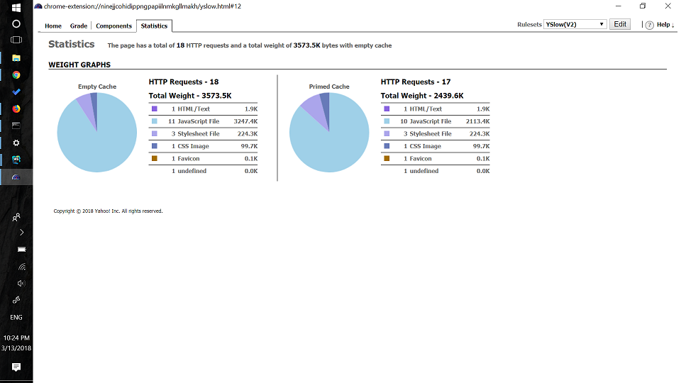

**Graded C in home page**

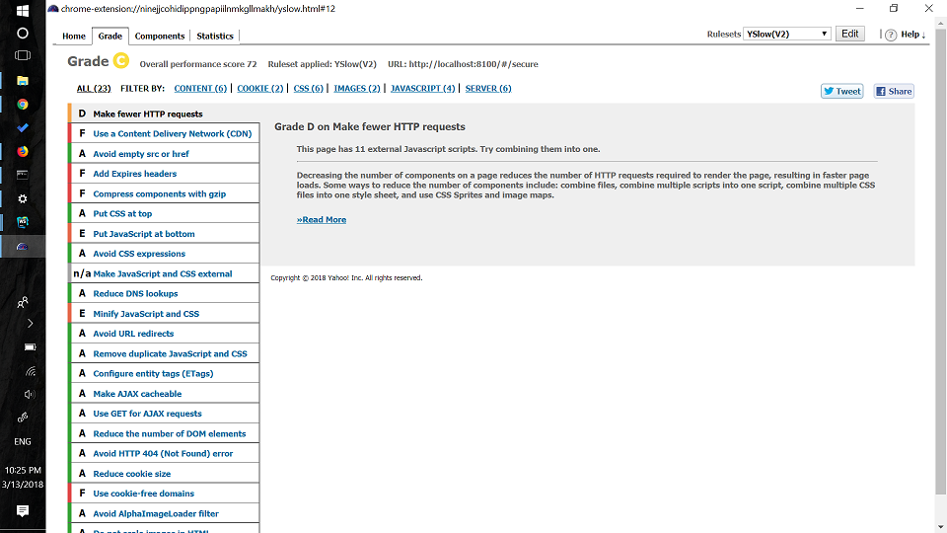

**Home page statistical report**

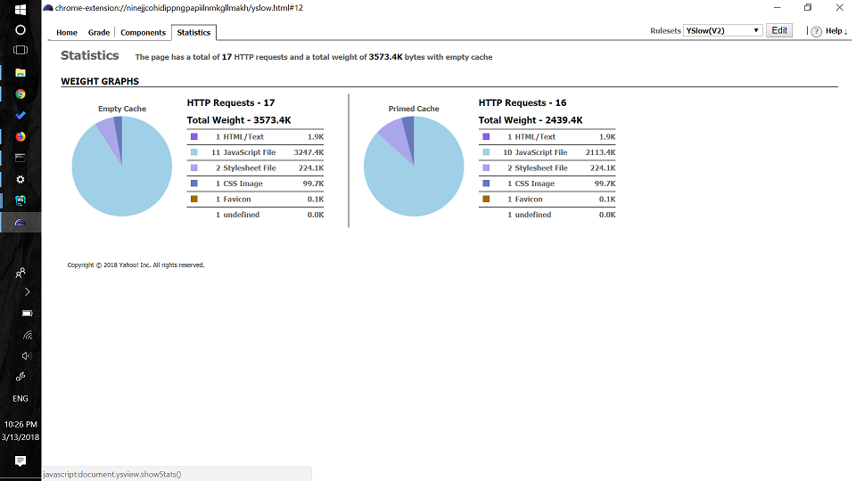

## ****G. Application Deployment****

1.The application is deployed and tested on both Web application and Android application

**Screenshots of application in mobile**

 

**Screenshots of application in web**

